Supplementary information for

**Substantial Reduction in Population Exposure to Sea Level Changes along the Coast of Chinese Mainland due to Mitigating Emissions**

Hu Jin1, Jiacan Yuan1,2*, Scott Kulp3, Hui Wang4, Dawei Li5, Guihua Wang1,6

1. Department of Atmospheric and Oceanic Sciences & Institute of Atmospheric Sciences & Shanghai Key Laboratory of Ocean-land-atmosphere Boundary Dynamics and Climate Change, Fudan University, Shanghai, China
2. Shanghai Frontiers Science Center of Atmosphere-Ocean Interaction, Fudan University, Shanghai, China
3. Climate Central, Princeton, NJ, USA
4. National Marine Data and Information Service, Tianjin, China
5. School of Oceanography, Shanghai Jiao Tong University, Shanghai, China
6. CMA-FDU Joint Laboratory of Marine Meteorology, Fudan University, Shanghai, China

*Corresponding author. Email: jcyuan@fudan.edu.cn

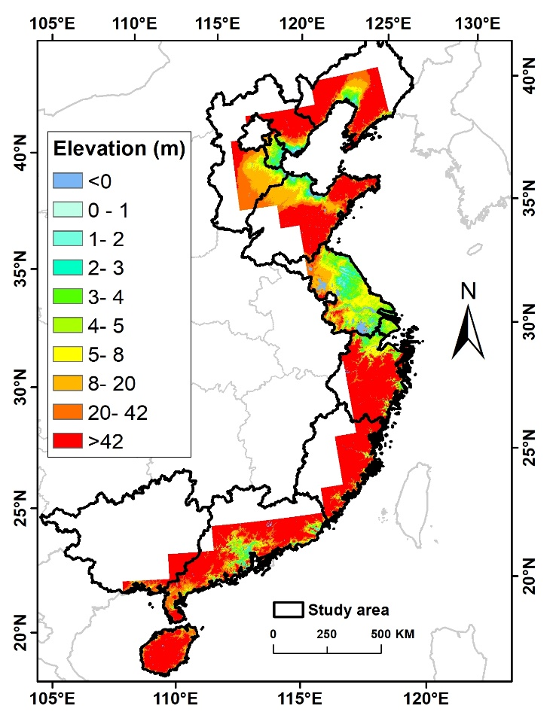

Figure S1. Provinces and municipalities (marked by thick solid line), and Elevation (shadings) along the coast of Chinese mainland

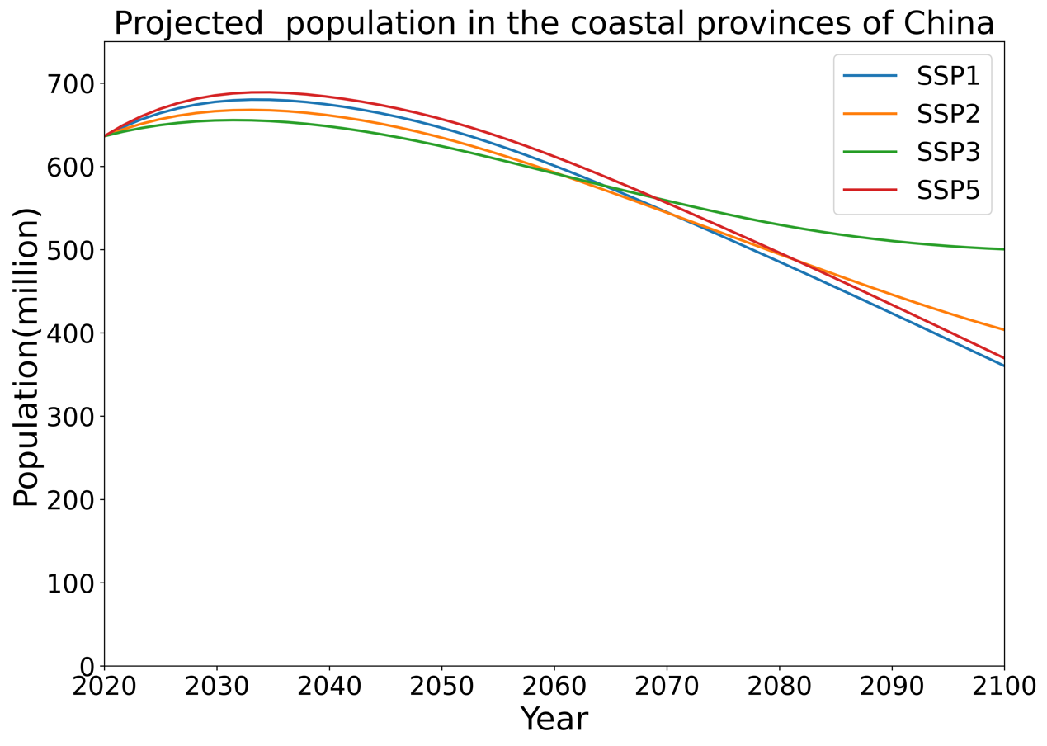

Figure S2. Projected population in the coastal provinces of mainland China from 2020 to 2100.

The future population under SSP1, SSP2, SSP3 and SSP5 scenarios are estimated from the Coastal Population Projections dataset. Between 2030 and 2040, there is little change in population. However, the population in coastal provinces of China will continue to decrease from 2040 to 2100. By the middle of the 21th century, the population under SSP1, SSP2, SSP3 and SSP5 scenarios will reach to 646.3 million, 634.5million, 624.2 million and 656.7 million, respectively. By the end of the 21th century, the population under SSP1, SSP2 and SSP5 scenarios will drop to 360.3 million, 403.7 million, 500.5 million and 369.6 million, respectively. The population of each scenario in 2100 is reduced by around 40% when compared to 2030. In the second half of the 21st century, the population of the long coastal areas of China is projected to decline. This is due to the diminishing population predicted by underlying demographic predictions after 2050, with the global population falling from 2050 to 2100 under SSP1, SSP2, SSP3 and SSP5[1].

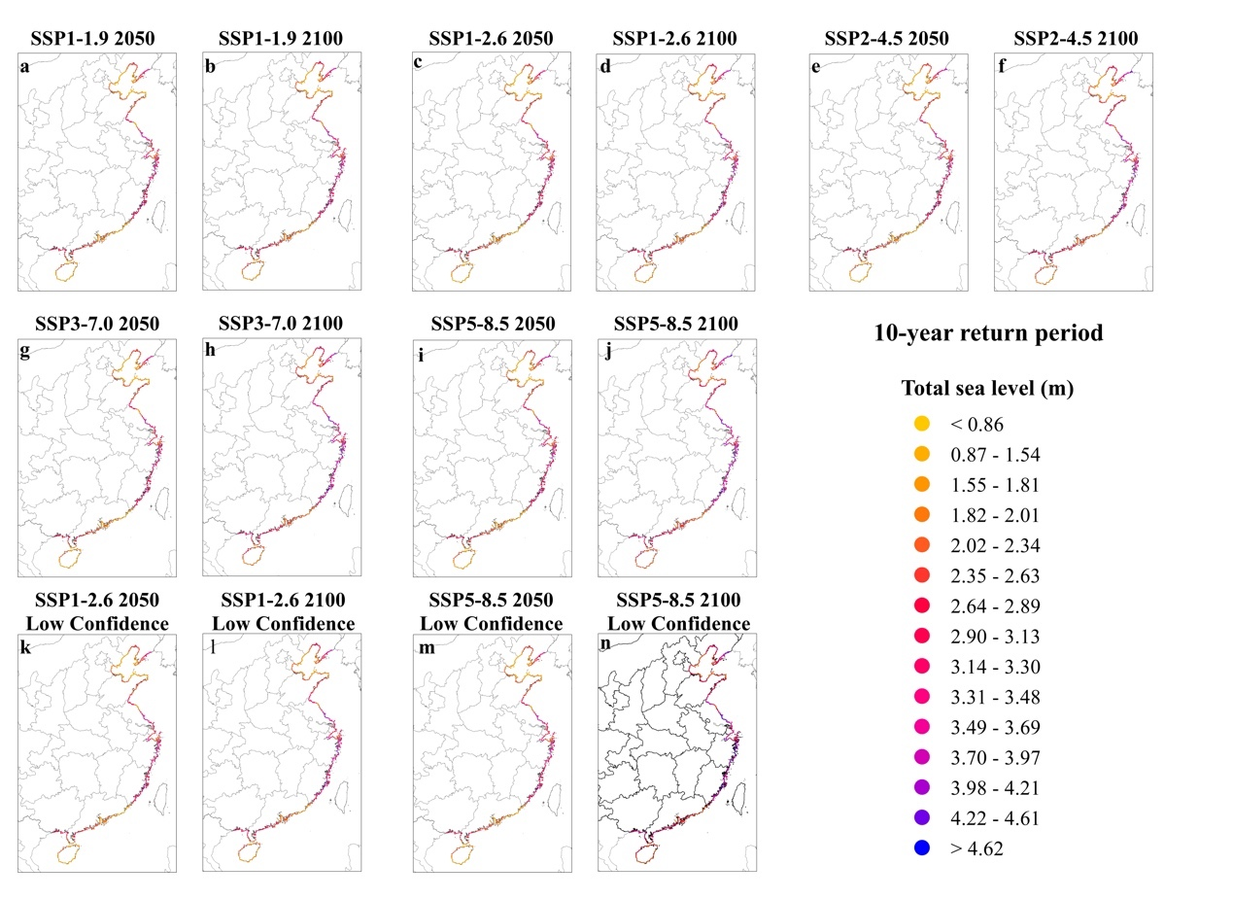

Figure S3. Total water level along the coast of mainland China (a-f), in 2050 and 2100 based on median estimation of RSLR for 7 scenarios and the 10-year return period ESL.

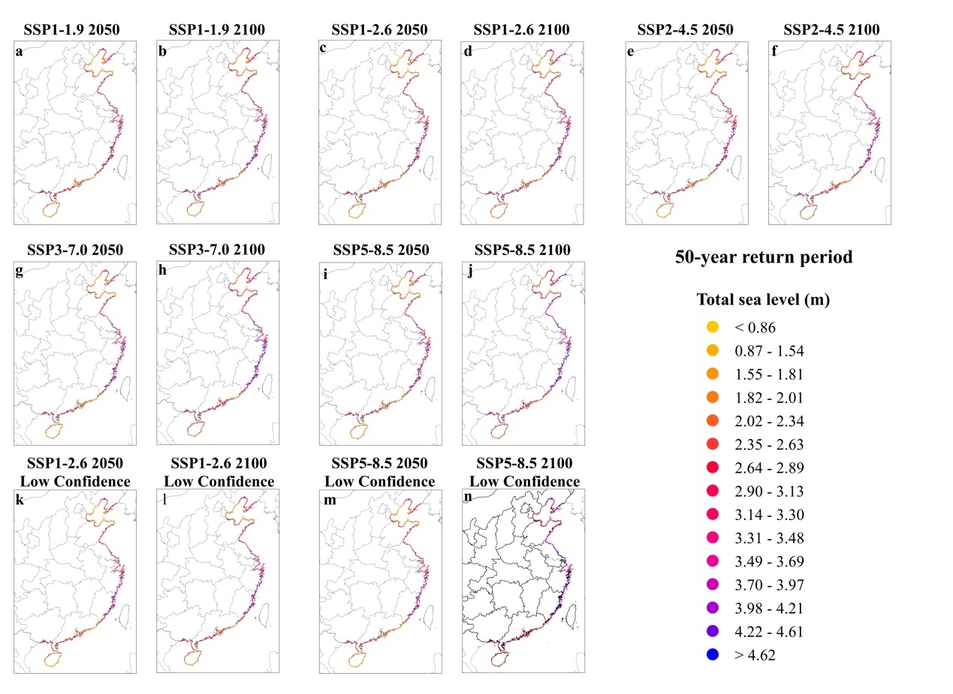

Figure S4. Total water level along the coast of mainland China (a-f), in 2050 and 2100 based on median estimation of RSLR for 7 scenarios and the 50-year return period ESL.

Figure S5. Total water level along the coast of mainland China (a-f), in 2050 and 2100 based on median estimation of RSLR for 7 scenarios and the 100-year return period ESL.

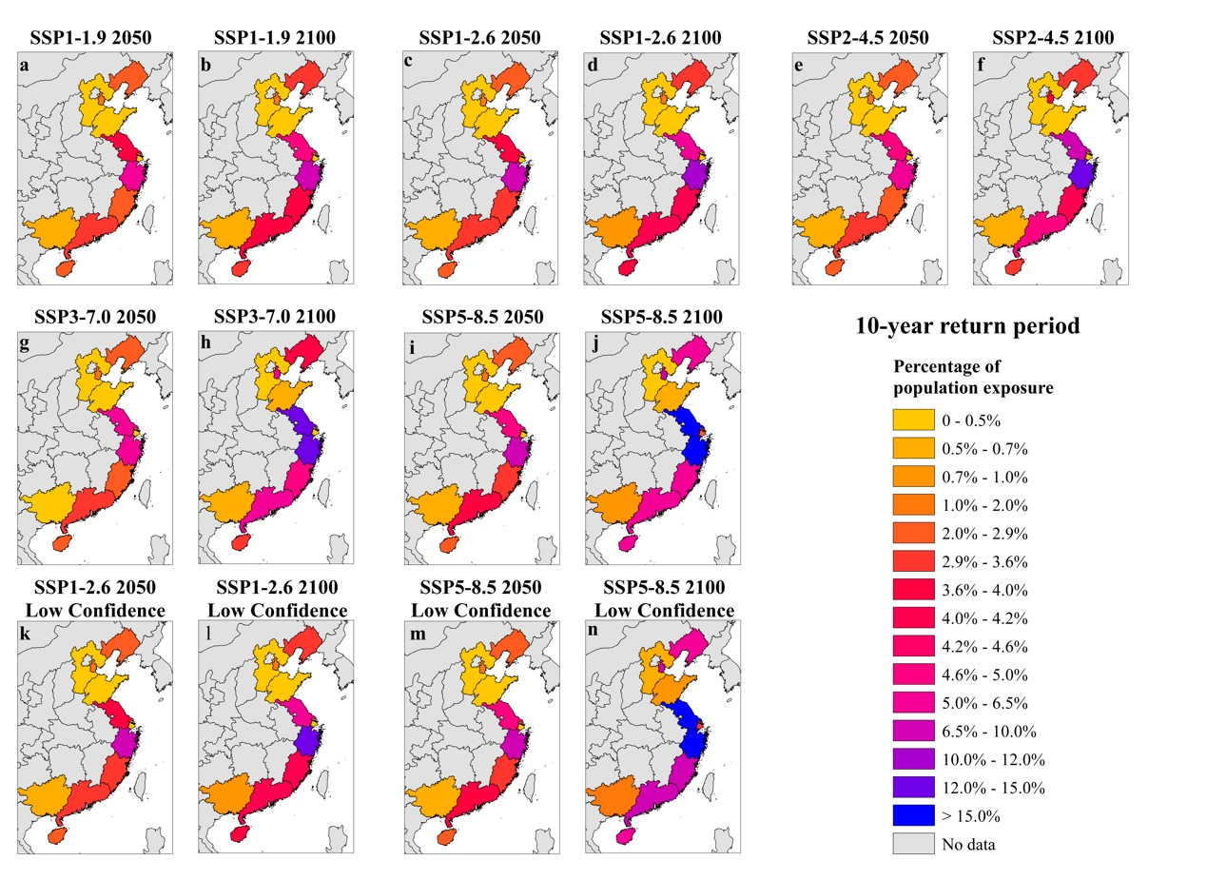

Figure S6. Median estimation of population exposure ratio in the coastal provinces of mainland China (a-f), in 2050 and 2100 for 7 scenarios for the 10-year return period flood.

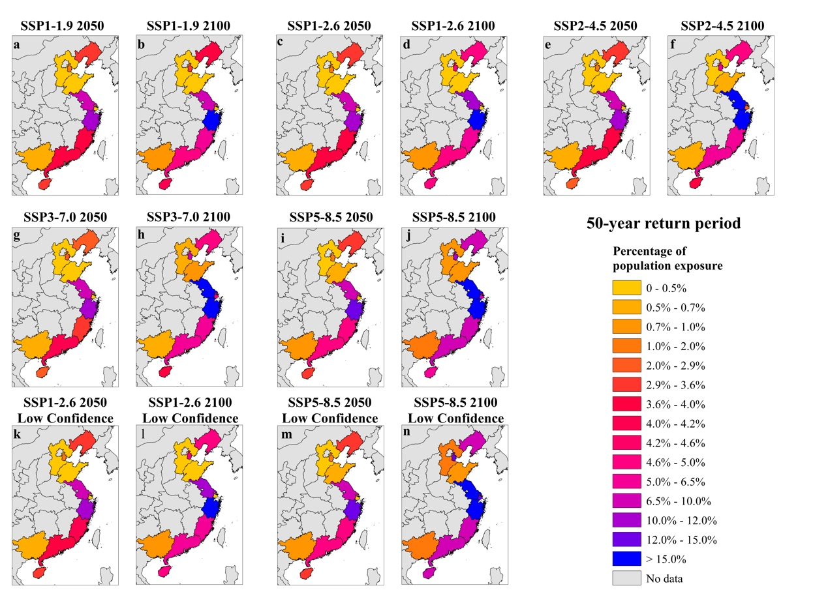

Figure S7. Median estimation of population exposure ratio in the coastal provinces of mainland China (a-f), in 2050 and 2100 for 7 scenarios for the 50-year return period flood.

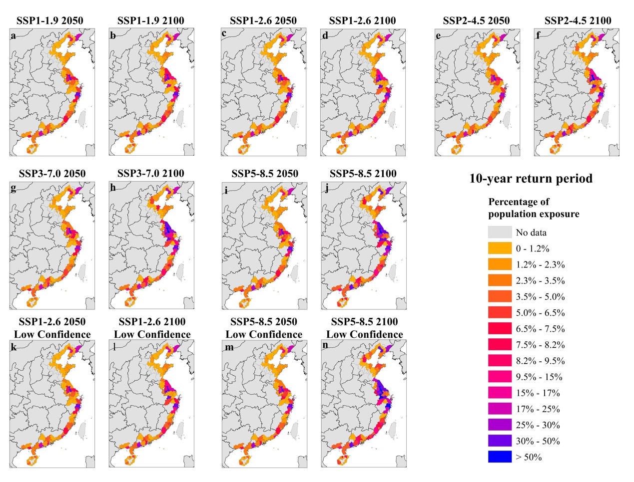

Figure S8. Estimated median ratio of population exposure in the coastal cities of mainland China (a-f), in 2050 and 2100 for 7 scenarios for the 10-year return period flood.

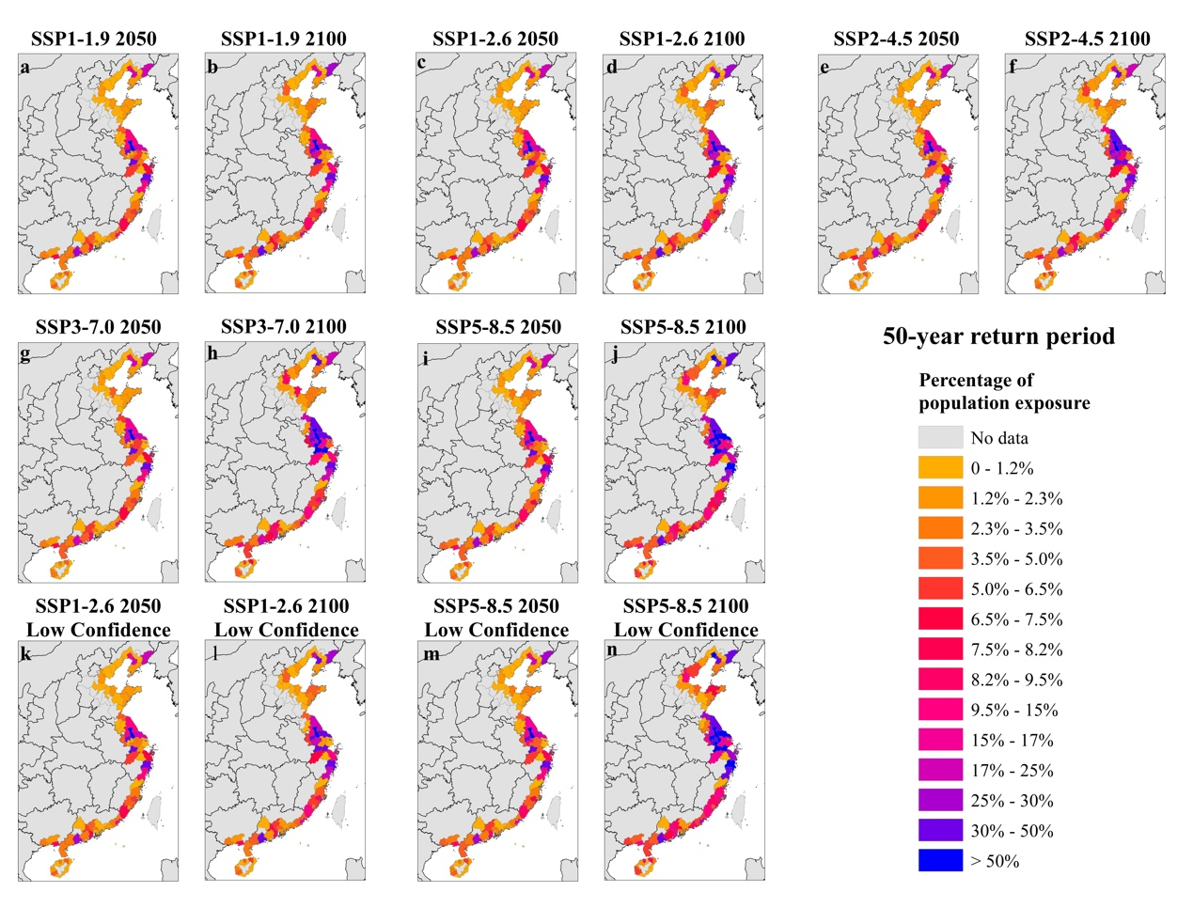

Figure S9. Estimated median ratio of population exposure in the coastal cities of mainland China (a-f), in 2050 and 2100 for 7 scenarios for the 50-year return period flood.

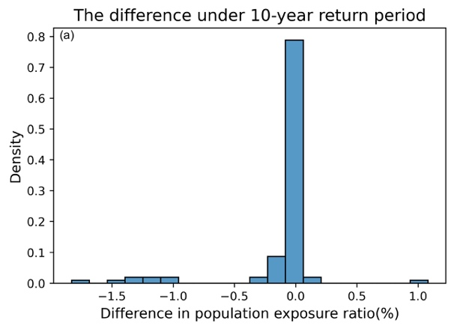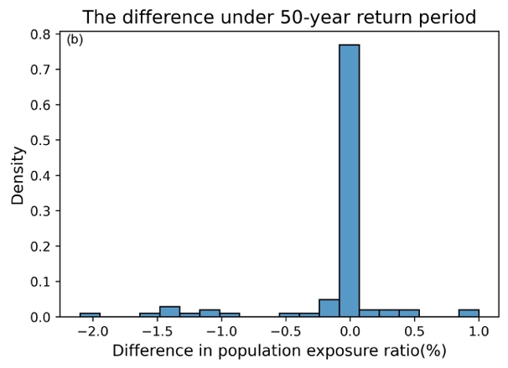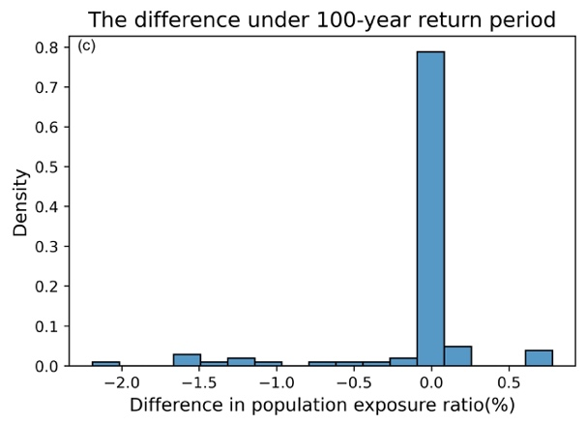

Figure S10. Probability density of differences between the projected population exposure ratio based on the two different datasets of flood protection under four GHGs-emission scenarios: SSP1-2.6, SSP2-4.5, SSP370 and SSP585 with (a) 10-year return period ESL; (b) 50-year return period ESL; (c) 100-year return period ESL.

Table S1. Projected inundation areas of mainland China from 2030 to 2100, for 7 scenarios under the 10-year return period flood. (unit: km2)

|  |  |  |  |  |  |  |  |  |  |
| --- | --- | --- | --- | --- | --- | --- | --- | --- | --- |
| Scenario | percentile | 2030 | 2040 | 2050 | 2060 | 2070 | 2080 | 2090 | 2100 |
| SSP1-1.9 | 17 | 18679 | 18872 | 19106 | 19051 | 19182 | 18920 | 19906 | 19070 |
| 50 | 20735 | 21852 | 21852 | 23030 | 24739 | 25708 | 27543 | 29262 |
| 83 | 22844 | 24622 | 27157 | 31721 | 33676 | 35949 | 40324 | 45679 |
| SSP1-2.6 | 17 | 18477 | 18712 | 19147 | 18937 | 20097 | 20434 | 20744 | 20841 |
| 50 | 20467 | 21834 | 23009 | 23556 | 25583 | 27191 | 29399 | 33145 |
| 83 | 22662 | 24063 | 27350 | 32193 | 34633 | 38553 | 44557 | 49508 |
| SSP2-4.5 | 17 | 18478 | 18930 | 19133 | 20233 | 21024 | 22121 | 22487 | 23510 |
| 50 | 20451 | 22032 | 22782 | 24796 | 26916 | 31518 | 33475 | 35927 |
| 83 | 22650 | 24692 | 27793 | 33609 | 36137 | 41861 | 51326 | 59521 |
| SSP3-7.0 | 17 | 18452 | 18996 | 19988 | 20766 | 22302 | 22936 | 25431 | 28158 |
| 50 | 20465 | 22216 | 22999 | 25512 | 28275 | 33044 | 36736 | 45175 |
| 83 | 22713 | 24887 | 28233 | 33196 | 38553 | 46959 | 58230 | 70632 |
| SSP5-8.5 | 17 | 18541 | 19210 | 20593 | 21909 | 22830 | 25487 | 29162 | 33518 |
| 50 | 20604 | 22441 | 23791 | 26748 | 32416 | 35378 | 41673 | 53381 |
| 83 | 22801 | 25427 | 29590 | 34843 | 41097 | 53708 | 64800 | 77976 |
| SSP1-2.6  Low Confidence | 17 | 18477 | 18712 | 19147 | 19284 | 20078 | 20432 | 20744 | 20836 |
| 50 | 20606 | 22094 | 22686 | 23889 | 25757 | 27753 | 31617 | 33723 |
| 83 | 22586 | 25598 | 29533 | 33879 | 38290 | 45164 | 53143 | 59687 |
| SSP5-8.5  Low Confidence | 17 | 18504 | 19138 | 20316 | 21696 | 22830 | 25487 | 29162 | 33518 |
| 50 | 20711 | 22535 | 23991 | 27352 | 33785 | 38142 | 48859 | 60606 |
| 83 | 22729 | 26915 | 33530 | 41312 | 57929 | 74107 | 91750 | 107442 |

*The inundation area under 10-year return period flood in the baseline period (2005) is 18033 km2

Table S2. Projected inundation areas of mainland China from 2030 to 2100, for 7 scenarios under the 50-year return period flood. (unit: km2)

|  |  |  |  |  |  |  |  |  |  |
| --- | --- | --- | --- | --- | --- | --- | --- | --- | --- |
| Scenario | percentile | 2030 | 2040 | 2050 | 2060 | 2070 | 2080 | 2090 | 2100 |
| SSP1-1.9 | 17 | 26248 | 26344 | 26720 | 26688 | 27009 | 27075 | 27402 | 27127 |
| 50 | 30168 | 31300 | 33268 | 33412 | 35145 | 37739 | 39238 | 40317 |
| 83 | 33146 | 34901 | 38972 | 41731 | 45708 | 53862 | 58362 | 61822 |
| SSP1-2.6 | 17 | 25926 | 26302 | 26920 | 27121 | 27599 | 29973 | 30209 | 30405 |
| 50 | 30012 | 31273 | 33563 | 33851 | 37501 | 39039 | 40495 | 42585 |
| 83 | 33116 | 34868 | 39082 | 42316 | 49668 | 56122 | 60555 | 65465 |
| SSP2-4.5 | 17 | 25923 | 26407 | 27402 | 27871 | 30518 | 32459 | 32534 | 34098 |
| 50 | 29992 | 31384 | 33034 | 35139 | 38731 | 41339 | 45138 | 53551 |
| 83 | 33106 | 34999 | 39508 | 43136 | 53134 | 59765 | 68695 | 76053 |
| SSP3-7.0 | 17 | 25894 | 26484 | 27589 | 30203 | 32659 | 33303 | 37151 | 39913 |
| 50 | 30009 | 32428 | 33348 | 35955 | 39980 | 44760 | 54485 | 61293 |
| 83 | 33172 | 35499 | 39799 | 45070 | 56097 | 63376 | 74154 | 85828 |
| SSP5-8.5 | 17 | 26070 | 27028 | 30072 | 32263 | 33164 | 37215 | 40200 | 45449 |
| 50 | 30082 | 32799 | 34162 | 38535 | 42415 | 51576 | 59625 | 70106 |
| 83 | 33092 | 35776 | 40853 | 50134 | 59183 | 70355 | 81696 | 94046 |
| SSP1-2.6  Low Confidence | 17 | 25926 | 26302 | 26920 | 27090 | 27568 | 29972 | 30209 | 30397 |
| 50 | 30087 | 32364 | 32914 | 34353 | 37871 | 39445 | 41454 | 44362 |
| 83 | 33652 | 37586 | 40776 | 46098 | 46098 | 61244 | 69680 | 76325 |
| SSP5-8.5  Low Confidence | 17 | 25957 | 26924 | 29914 | 31163 | 33164 | 37215 | 40200 | 45449 |
| 50 | 30140 | 32960 | 34803 | 39078 | 44443 | 55663 | 64389 | 77372 |
| 83 | 32966 | 38731 | 45750 | 59383 | 73864 | 89799 | 103830 | 118404 |

*The inundation area under 50-year return period flood in the baseline period (2005) is 25239 km2

Table S3. Projected inundation areas of mainland China from 2030 to 2100, for 7 scenarios under the 100-year return period flood. (unit: km2)

|  |  |  |  |  |  |  |  |  |  |
| --- | --- | --- | --- | --- | --- | --- | --- | --- | --- |
| Scenario | percentile | 2030 | 2040 | 2050 | 2060 | 2070 | 2080 | 2090 | 2100 |
| SSP1-1.9 | 17 | 31446 | 31568 | 32673 | 32657 | 32843 | 32942 | 33467 | 33104 |
| 50 | 33512 | 35019 | 37802 | 38868 | 40796 | 41681 | 44463 | 46072 |
| 83 | 37711 | 40580 | 44124 | 48514 | 56156 | 59648 | 64053 | 70329 |
| SSP1-2.6 | 17 | 31235 | 31524 | 32759 | 33008 | 32790 | 33325 | 33728 | 33956 |
| 50 | 33281 | 34688 | 37893 | 39300 | 41483 | 44298 | 46455 | 52071 |
| 83 | 37543 | 40542 | 44336 | 49285 | 57609 | 61432 | 66167 | 74014 |
| SSP2-4.5 | 17 | 31234 | 31637 | 33239 | 32946 | 34049 | 36558 | 37876 | 39424 |
| 50 | 33266 | 35247 | 38421 | 40783 | 43859 | 48115 | 55415 | 59584 |
| 83 | 37530 | 40653 | 44803 | 53508 | 59635 | 65575 | 75240 | 82867 |
| SSP3-7.0 | 17 | 31191 | 31798 | 33658 | 33669 | 36807 | 38690 | 42397 | 45597 |
| 50 | 33279 | 35556 | 38798 | 42434 | 45272 | 54973 | 60262 | 68719 |
| 83 | 37608 | 41012 | 45172 | 55377 | 61531 | 72109 | 81130 | 93007 |
| SSP5-8.5 | 17 | 31314 | 32897 | 33408 | 35060 | 38498 | 42366 | 45890 | 55913 |
| 50 | 31314 | 36910 | 39704 | 42600 | 49567 | 58784 | 65341 | 76964 |
| 83 | 37653 | 41280 | 47142 | 57978 | 65093 | 77198 | 88414 | 98491 |
| SSP1-2.6  Low Confidence | 17 | 31235 | 31524 | 32759 | 32974 | 32712 | 33323 | 33728 | 33947 |
| 50 | 33423 | 35364 | 38222 | 39991 | 41849 | 44729 | 48081 | 54353 |
| 83 | 38105 | 41631 | 46890 | 56630 | 61293 | 68661 | 76760 | 83189 |
| SSP5-8.5  Low Confidence | 17 | 31271 | 32757 | 33197 | 34570 | 38498 | 42366 | 45890 | 55913 |
| 50 | 33477 | 37339 | 40497 | 44357 | 54670 | 61076 | 72794 | 84366 |
| 83 | 38279 | 43885 | 55772 | 65241 | 80667 | 95872 | 109213 | 121616 |

*The inundation area under 100-year return period flood in the baseline period (2005) is 30857 km2

Table S4. Total exposed population of mainland China from 2030 to 2100, for 7 scenarios under the 10-year return period flood. (million)

|  |  |  |  |  |  |  |  |  |  |
| --- | --- | --- | --- | --- | --- | --- | --- | --- | --- |
| Scenario | percentile | 2030 | 2040 | 2050 | 2060 | 2070 | 2080 | 2090 | 2100 |
| SSP1-1.9 | 17 | 13.4 | 13.4 | 13.0 | 12.1 | 11.1 | 9.8 | 8.7 | 7.3 |
| 50 | 14.7 | 15.1 | 15.1 | 14.4 | 13.9 | 12.8 | 12.1 | 10.9 |
| 83 | 16.0 | 17.2 | 18.2 | 19.1 | 19.4 | 18.6 | 19.0 | 18.2 |
| SSP1-2.6 | 17 | 13.3 | 13.3 | 13.1 | 12.2 | 11.4 | 10.3 | 9.1 | 7.8 |
| 50 | 14.7 | 15.1 | 15.2 | 14.9 | 14.2 | 13.7 | 12.9 | 12.2 |
| 83 | 15.9 | 17.1 | 18.4 | 19.6 | 20.0 | 20.0 | 20.6 | 20.0 |
| SSP2-4.5 | 17 | 13.1 | 13.2 | 11.9 | 12.3 | 11.6 | 10.9 | 10.0 | 9.6 |
| 50 | 14.4 | 15.0 | 15.0 | 15.1 | 14.9 | 15.3 | 15.2 | 14.8 |
| 83 | 15.8 | 17.1 | 18.3 | 20.4 | 20.5 | 22.2 | 24.3 | 26.0 |
| SSP3-7.0 | 17 | 13.0 | 13.3 | 13.3 | 13.0 | 13.0 | 12.9 | 13.6 | 14.8 |
| 50 | 14.4 | 15.2 | 15.4 | 16.0 | 16.8 | 18.8 | 20.5 | 24.7 |
| 83 | 15.8 | 17.3 | 18.8 | 21.2 | 23.4 | 27.6 | 33.5 | 41.8 |
| SSP5-8.5 | 17 | 14.3 | 14.7 | 14.9 | 14.7 | 14.2 | 14.1 | 14.2 | 14.3 |
| 50 | 15.7 | 16.8 | 17.6 | 18.2 | 19.7 | 20.1 | 21.8 | 24.1 |
| 83 | 17.2 | 19.2 | 21.7 | 24.3 | 27.3 | 32.2 | 35.5 | 39.2 |
| SSP1-2.6  Low Confidence | 17 | 13.3 | 13.3 | 13.1 | 12.2 | 11.4 | 10.3 | 9.1 | 7.8 |
| 50 | 14.6 | 15.2 | 15.3 | 15.1 | 14.4 | 13.9 | 13.4 | 12.4 |
| 83 | 16.1 | 17.8 | 19.9 | 19.6 | 22.3 | 24.0 | 25.2 | 24.4 |
| SSP5-8.5  Low Confidence | 17 | 14.2 | 14.7 | 14.9 | 14.6 | 14.2 | 14.1 | 14.2 | 14.3 |
| 50 | 14.7 | 16.9 | 17.8 | 18.7 | 20.9 | 21.9 | 25.6 | 28.3 |
| 83 | 17.4 | 20.5 | 25.0 | 30.2 | 39.2 | 48.7 | 58.7 | 63.0 |

*The population exposure under 10-year return period flood in the baseline period (2005) is 11.3 million.

Table S5. Total exposed population of mainland China from 2030 to 2100, for 7 scenarios under the 50-year return period flood. (million)

|  |  |  |  |  |  |  |  |  |  |
| --- | --- | --- | --- | --- | --- | --- | --- | --- | --- |
| Scenario | percentile | 2030 | 2040 | 2050 | 2060 | 2070 | 2080 | 2090 | 2100 |
| SSP1-1.9 | 17 | 18.8 | 18.7 | 18.1 | 16.8 | 15.3 | 13.7 | 12.1 | 10.2 |
| 50 | 21 | 21.8 | 22.3 | 21.4 | 20.7 | 19.5 | 18.2 | 16.0 |
| 83 | 23.6 | 25.6 | 27.3 | 28.0 | 28.2 | 29.3 | 28.2 | 25.8 |
| SSP1-2.6 | 17 | 18.6 | 18.7 | 18.2 | 17.0 | 15.7 | 14.5 | 12.8 | 10.9 |
| 50 | 20.8 | 21.8 | 22.6 | 21.7 | 21.7 | 20.7 | 18.9 | 17.3 |
| 83 | 23.5 | 25.6 | 27.7 | 28.5 | 30.0 | 30.6 | 29.3 | 27.8 |
| SSP2-4.5 | 17 | 18.5 | 18.5 | 18.1 | 17.2 | 16.5 | 16.0 | 14.9 | 14.3 |
| 50 | 20.8 | 21.7 | 22.3 | 22.3 | 22.3 | 22.1 | 22.0 | 23.1 |
| 83 | 23.4 | 25.2 | 27.4 | 28.4 | 31.6 | 32.7 | 34.8 | 35.6 |
| SSP3-7.0 | 17 | 18.5 | 18.6 | 18.5 | 18.7 | 19.3 | 19.1 | 20.6 | 22.1 |
| 50 | 20.8 | 22.5 | 22.8 | 23.4 | 24.9 | 27.1 | 31.4 | 35.2 |
| 83 | 23.5 | 25.5 | 28.0 | 30.6 | 35.6 | 39.1 | 45.6 | 53.7 |
| SSP5-8.5 | 17 | 20.1 | 20.7 | 21.4 | 21.8 | 21.2 | 21.3 | 20.8 | 20.8 |
| 50 | 22.5 | 24.8 | 26.3 | 27.4 | 28.6 | 30.7 | 32.1 | 34.0 |
| 83 | 25.3 | 28.3 | 31.7 | 39.0 | 40.5 | 45.3 | 48.9 | 50.7 |
| SSP1-2.6  Low Confidence | 17 | 18.6 | 18.7 | 18.2 | 17.0 | 15.7 | 14.5 | 12.8 | 10.9 |
| 50 | 20.9 | 22.5 | 22.7 | 22.5 | 22.1 | 21.0 | 19.5 | 18.1 |
| 83 | 24.1 | 27.3 | 29.1 | 31.3 | 34.3 | 34.2 | 35.4 | 33.9 |
| SSP5-8.5  Low Confidence | 17 | 18.7 | 20.6 | 21.2 | 21.1 | 21.2 | 21.3 | 20.8 | 20.8 |
| 50 | 22.5 | 25.0 | 26.6 | 28.1 | 30.2 | 33.6 | 35.8 | 38.5 |
| 83 | 25.8 | 30.7 | 36.3 | 44.6 | 54.0 | 63.9 | 69.7 | 71.7 |

*The population exposure under 50-year return period flood in the baseline period (2005) is 16.1 million.

Table S6. Total exposed population of mainland China from 2030 to 2100, for 7 scenarios under the 100-year return period flood. (million)

|  |  |  |  |  |  |  |  |  |  |
| --- | --- | --- | --- | --- | --- | --- | --- | --- | --- |
| Scenario | percentile | 2030 | 2040 | 2050 | 2060 | 2070 | 2080 | 2090 | 2100 |
| SSP1-1.9 | 17 | 22.3 | 22.1 | 21.8 | 20.2 | 18.4 | 16.4 | 14.5 | 12.2 |
| 50 | 25.1 | 26.2 | 26.3 | 25.7 | 24.6 | 22.7 | 21.4 | 18.8 |
| 83 | 27.8 | 30.4 | 32.3 | 32.7 | 34.9 | 33.0 | 31.6 | 30.5 |
| SSP1-2.6 | 17 | 22.2 | 22.1 | 21.9 | 20.5 | 18.9 | 17.7 | 15.6 | 13.3 |
| 50 | 24.4 | 25.7 | 26.4 | 25.9 | 25.2 | 24.4 | 22.2 | 20.9 |
| 83 | 27.7 | 30.4 | 32.4 | 33.2 | 35.7 | 34.5 | 33.2 | 32.4 |
| SSP2-4.5 | 17 | 22.1 | 22.0 | 21.9 | 20.5 | 19.8 | 18.9 | 17.5 | 16.7 |
| 50 | 24.2 | 25.8 | 26.6 | 26.4 | 26.4 | 26.0 | 27.1 | 26.2 |
| 83 | 27.5 | 29.9 | 32.1 | 35.2 | 36.1 | 37.0 | 38.8 | 40.3 |
| SSP3-7.0 | 17 | 22.1 | 22.2 | 22.5 | 22.2 | 22.5 | 22.8 | 24.0 | 25.9 |
| 50 | 24.1 | 26.0 | 27.2 | 28.1 | 29.1 | 33.4 | 35.4 | 41.1 |
| 83 | 27.5 | 30.1 | 32.6 | 37.7 | 40.0 | 45.6 | 51.4 | 59.2 |
| SSP5-8.5 | 17 | 23.9 | 25.1 | 25.8 | 25.6 | 25.4 | 25.1 | 24.6 | 25.7 |
| 50 | 23.9 | 29.2 | 30.7 | 31.7 | 33.3 | 35.9 | 36.3 | 37.9 |
| 83 | 29.8 | 33.5 | 37.3 | 43.3 | 45.7 | 50.4 | 54.3 | 54.9 |
| SSP1-2.6  Low Confidence | 17 | 22.2 | 22.1 | 21.9 | 20.5 | 18.9 | 17.7 | 15.6 | 13.3 |
| 50 | 25 | 26.4 | 26.8 | 26.3 | 25.5 | 24.7 | 23.0 | 22.3 |
| 83 | 28.3 | 38.7 | 34.2 | 38.7 | 38.6 | 40.3 | 39.6 | 38.6 |
| SSP5-8.5  Low Confidence | 17 | 23.9 | 24.9 | 25.0 | 24.9 | 25.4 | 25.1 | 24.6 | 25.7 |
| 50 | 26.9 | 29.4 | 31.6 | 33.1 | 40.9 | 37.9 | 41.7 | 44.5 |
| 83 | 30.6 | 36.2 | 44.8 | 50.4 | 61.4 | 69.4 | 73.6 | 75.2 |

*The population exposure under 100-year return period flood in the baseline period (2005) is 20.0 million.

Table S7. Ratio of total population exposure of mainland China from 2030 to 2100, for 7 scenarios under the 10-year return period flood. (%)

|  |  |  |  |  |  |  |  |  |  |
| --- | --- | --- | --- | --- | --- | --- | --- | --- | --- |
| Scenario | percentile | 2030 | 2040 | 2050 | 2060 | 2070 | 2080 | 2090 | 2100 |
| SSP1-1.9 | 17 | 2.0 | 2.0 | 2.0 | 2.0 | 2.0 | 2.0 | 2.1 | 2.0 |
| 50 | 2.2 | 2.2 | 2.3 | 2.4 | 2.6 | 2.6 | 2.8 | 3.0 |
| 83 | 2.4 | 2.6 | 2.8 | 3.2 | 3.6 | 3.8 | 4.5 | 5.0 |
| SSP1-2.6 | 17 | 2.0 | 2.0 | 2.0 | 2.0 | 2.1 | 2.1 | 2.1 | 2.2 |
| 50 | 2.2 | 2.2 | 2.3 | 2.5 | 2.6 | 2.8 | 3.0 | 3.4 |
| 83 | 2.3 | 2.5 | 2.8 | 3.3 | 3.7 | 4.1 | 4.9 | 5.5 |
| SSP2-4.5 | 17 | 2.0 | 2.0 | 1.9 | 2.1 | 2.1 | 2.2 | 2.2 | 2.4 |
| 50 | 2.2 | 2.3 | 2.4 | 2.5 | 2.7 | 3.1 | 3.4 | 3.7 |
| 83 | 2.4 | 2.6 | 2.9 | 3.4 | 3.8 | 4.5 | 5.4 | 6.4 |
| SSP3-7.0 | 17 | 2.0 | 2.0 | 2.1 | 2.2 | 2.3 | 2.4 | 2.7 | 3.0 |
| 50 | 2.2 | 2.3 | 2.5 | 2.7 | 3.0 | 3.5 | 4.0 | 4.9 |
| 83 | 2.4 | 2.7 | 3.0 | 3.6 | 4.2 | 5.2 | 6.6 | 8.4 |
| SSP5-8.5 | 17 | 2.1 | 2.1 | 2.3 | 2.4 | 2.6 | 2.8 | 3.3 | 3.9 |
| 50 | 2.3 | 2.5 | 2.7 | 3.0 | 3.5 | 4.1 | 5.0 | 6.5 |
| 83 | 2.5 | 2.8 | 3.3 | 4.0 | 4.9 | 6.5 | 8.2 | 10.6 |
| SSP1-2.6  Low Confidence | 17 | 2.0 | 2.0 | 2.0 | 2.0 | 2.1 | 2.1 | 2.1 | 2.2 |
| 50 | 2.2 | 2.3 | 2.4 | 2.5 | 2.6 | 2.9 | 3.2 | 3.5 |
| 83 | 2.4 | 2.6 | 3.1 | 3.3 | 4.1 | 4.9 | 6.0 | 6.8 |
| SSP5-8.5  Low Confidence | 17 | 2.1 | 2.2 | 2.3 | 2.4 | 2.6 | 2.8 | 3.3 | 3.9 |
| 50 | 2.1 | 2.5 | 2.7 | 3.1 | 3.8 | 4.4 | 5.9 | 7.6 |
| 83 | 2.5 | 3.0 | 3.8 | 4.9 | 7.0 | 9.8 | 13.5 | 17.0 |

*The ratio of total population exposure under 10-year return period flood in the baseline period (2005) is 2.0%.

Table S8. Ratio of total population exposure of mainland China from 2030 to 2100, for 7 scenarios­ under the 50-year return period flood. (%)

|  |  |  |  |  |  |  |  |  |  |
| --- | --- | --- | --- | --- | --- | --- | --- | --- | --- |
| Scenario | percentile | 2030 | 2040 | 2050 | 2060 | 2070 | 2080 | 2090 | 2100 |
| SSP1-1.9 | 17 | 2.8 | 2.8 | 2.8 | 2.8 | 2.8 | 2.8 | 2.8 | 2.8 |
| 50 | 3.1 | 3.2 | 3.4 | 3.6 | 3.8 | 4.0 | 4.3 | 4.4 |
| 83 | 3.5 | 3.8 | 4.2 | 4.7 | 5.2 | 6.0 | 6.7 | 7.2 |
| SSP1-2.6 | 17 | 2.8 | 2.8 | 2.8 | 2.8 | 2.9 | 3.0 | 3.0 | 3.0 |
| 50 | 3.1 | 3.2 | 3.5 | 3.6 | 4.0 | 4.3 | 4.5 | 4.8 |
| 83 | 3.5 | 3.8 | 4.3 | 4.7 | 5.5 | 6.3 | 6.9 | 7.7 |
| SSP2-4.5 | 17 | 2.8 | 2.8 | 2.9 | 2.9 | 3.0 | 3.2 | 3.3 | 3.5 |
| 50 | 3.1 | 3.3 | 3.5 | 3.8 | 4.1 | 4.5 | 4.9 | 5.7 |
| 83 | 3.5 | 3.8 | 4.3 | 4.8 | 5.8 | 6.6 | 7.8 | 8.8 |
| SSP3-7.0 | 17 | 2.8 | 2.9 | 3.0 | 3.2 | 3.5 | 3.6 | 4.0 | 4.4 |
| 50 | 3.2 | 3.5 | 3.7 | 4.0 | 4.5 | 5.1 | 6.2 | 7.0 |
| 83 | 3.6 | 3.9 | 4.5 | 5.2 | 6.4 | 7.4 | 8.9 | 10.7 |
| SSP5-8.5 | 17 | 2.9 | 3.0 | 3.3 | 3.6 | 3.8 | 4.3 | 4.8 | 5.6 |
| 50 | 3.3 | 3.6 | 4.0 | 4.5 | 5.1 | 6.2 | 7.4 | 9.2 |
| 83 | 3.7 | 4.1 | 4.8 | 6.4 | 7.3 | 9.1 | 11.3 | 13.7 |
| SSP1-2.6  Low Confidence | 17 | 2.8 | 2.8 | 2.8 | 2.8 | 2.9 | 3.0 | 3.0 | 3.0 |
| 50 | 3.1 | 3.3 | 3.5 | 3.7 | 4.1 | 4.3 | 4.6 | 5.0 |
| 83 | 3.6 | 4.0 | 4.5 | 5.2 | 6.3 | 7.0 | 8.4 | 9.4 |
| SSP5-8.5  Low Confidence | 17 | 2.7 | 3.0 | 3.2 | 3.4 | 3.8 | 4.3 | 4.8 | 5.6 |
| 50 | 3.3 | 3.7 | 4.0 | 4.6 | 5.4 | 6.8 | 8.2 | 10.4 |
| 83 | 3.8 | 4.5 | 5.5 | 7.3 | 9.7 | 12.9 | 16.1 | 19.4 |

*The ratio of total population exposure under 50-year return period flood in the baseline period (2005) is 2.9%.

Table S9. Ratio of total population exposure of mainland China from 2030 to 2100, for 7 scenarios under the 100-year return period flood. (%)

|  |  |  |  |  |  |  |  |  |  |
| --- | --- | --- | --- | --- | --- | --- | --- | --- | --- |
| Scenario | percentile | 2030 | 2040 | 2050 | 2060 | 2070 | 2080 | 2090 | 2100 |
| SSP1-1.9 | 17 | 3.3 | 3.3 | 3.4 | 3.4 | 3.4 | 3.4 | 3.4 | 3.4 |
| 50 | 3.7 | 3.9 | 4.1 | 4.3 | 4.5 | 4.7 | 5.1 | 5.2 |
| 83 | 4.1 | 4.5 | 5.0 | 5.4 | 6.4 | 6.8 | 7.5 | 8.5 |
| SSP1-2.6 | 17 | 3.3 | 3.3 | 3.4 | 3.4 | 3.5 | 3.6 | 3.7 | 3.7 |
| 50 | 3.6 | 3.8 | 4.1 | 4.3 | 4.6 | 5.0 | 5.3 | 5.8 |
| 83 | 4.1 | 4.5 | 5.0 | 5.5 | 6.6 | 7.1 | 7.8 | 9.0 |
| SSP2-4.5 | 17 | 3.3 | 3.3 | 3.5 | 3.5 | 3.6 | 3.8 | 3.9 | 4.1 |
| 50 | 3.6 | 3.9 | 4.2 | 4.5 | 4.8 | 5.2 | 6.1 | 6.5 |
| 83 | 4.1 | 4.5 | 5.1 | 5.9 | 6.6 | 7.5 | 8.7 | 10.0 |
| SSP3-7.0 | 17 | 3.4 | 3.4 | 3.6 | 3.7 | 4.0 | 4.3 | 4.7 | 5.2 |
| 50 | 3.7 | 4.0 | 4.4 | 4.8 | 5.2 | 6.3 | 6.9 | 8.2 |
| 83 | 4.2 | 4.6 | 5.2 | 6.4 | 7.2 | 8.6 | 10.1 | 11.8 |
| SSP5-8.5 | 17 | 3.5 | 3.7 | 3.9 | 4.2 | 4.6 | 5.1 | 5.7 | 7.0 |
| 50 | 3.5 | 4.3 | 4.7 | 5.2 | 6.0 | 7.2 | 8.4 | 10.2 |
| 83 | 4.3 | 4.9 | 5.7 | 7.1 | 8.2 | 10.2 | 12.5 | 14.8 |
| SSP1-2.6  Low Confidence | 17 | 3.3 | 3.3 | 3.4 | 3.4 | 3.5 | 3.6 | 3.7 | 3.7 |
| 50 | 3.7 | 3.9 | 4.2 | 4.4 | 4.7 | 5.1 | 5.4 | 6.2 |
| 83 | 4.2 | 5.7 | 5.3 | 6.4 | 7.1 | 8.3 | 9.4 | 10.7 |
| SSP5-8.5  Low Confidence | 17 | 3.5 | 3.6 | 3.8 | 4.1 | 4.6 | 5.1 | 5.7 | 7.0 |
| 50 | 3.9 | 4.3 | 4.8 | 5.4 | 6.8 | 8.2 | 9.6 | 12.0 |
| 83 | 4.5 | 5.3 | 6.8 | 8.2 | 11.0 | 14.0 | 17.0 | 20.4 |

*The ratio of total population exposure under 10-year return period flood in the baseline period (2005) is 3.6%.

Table S10. Median estimation of population exposure ratio in the coastal provinces of mainland China, in 2050 and 2100 for 7 scenarios under the 10-year return period flood. (%)

|  |  |  |  |  |  |  |  |  |  |  |  |  |  |  |
| --- | --- | --- | --- | --- | --- | --- | --- | --- | --- | --- | --- | --- | --- | --- |
| 10-year return period | SSP1-1.9 | | SSP1-2.6 | | SSP2-4.5 | | SSP3-7.0 | | SSP5-8.5 | | SSP1-2.6  Low Confidence | | SSP5-8.5  Low Confidence | |
| 2050 | 2100 | 2050 | 2100 | 2050 | 2100 | 2050 | 2100 | 2050 | 2100 | 2050 | 2100 | 2050 | 2100 |
| Fujian | 2.97 | 3.85 | 2.98 | 4.03 | 2.78 | 4.00 | 2.67 | 4.21 | 3.29 | 6.01 | 3.01 | 4.11 | 3.32 | 6.65 |
| Guangdong | 3.40 | 3.98 | 3.41 | 4.13 | 3.41 | 4.39 | 3.52 | 5.10 | 3.75 | 6.20 | 3.43 | 4.20 | 3.78 | 7.11 |
| Guangxi | 0.56 | 0.69 | 0.56 | 0.71 | 0.52 | 0.63 | 0.49 | 0.60 | 0.64 | 0.96 | 0.56 | 0.72 | 0.65 | 1.01 |
| Hainan | 2.62 | 3.54 | 2.62 | 3.71 | 2.29 | 3.44 | 2.06 | 3.24 | 2.87 | 5.55 | 2.64 | 3.78 | 2.90 | 6.12 |
| Hebei | 0.08 | 0.10 | 0.08 | 0.14 | 0.10 | 0.20 | 0.13 | 0.35 | 0.11 | 0.44 | 0.09 | 0.15 | 0.12 | 0.51 |
| Hong Kong | 1.11 | 1.23 | 1.11 | 1.27 | 1.02 | 1.16 | 1.08 | 1.39 | 1.12 | 1.55 | 1.12 | 1.29 | 1.13 | 1.76 |
| Jiangsu | 3.84 | 4.69 | 3.85 | 5.58 | 4.65 | 7.51 | 5.50 | 14.48 | 4.50 | 15.38 | 3.84 | 5.77 | 4.57 | 18.92 |
| Liaoning | 2.51 | 3.14 | 2.52 | 3.36 | 2.33 | 3.23 | 2.25 | 3.79 | 2.80 | 5.87 | 2.53 | 3.40 | 2.82 | 6.37 |
| Macau | 1.40 | 1.88 | 1.40 | 1.94 | 1.40 | 2.41 | 1.39 | 2.61 | 1.45 | 3.26 | 1.40 | 2.11 | 1.45 | 3.78 |
| Shandong | 0.35 | 0.40 | 0.35 | 0.42 | 0.37 | 0.46 | 0.39 | 0.62 | 0.42 | 0.68 | 0.36 | 0.42 | 0.43 | 0.78 |
| Shanghai | 0.10 | 0.03 | 0.10 | 0.03 | 0.20 | 0.13 | 0.33 | 0.38 | 0.13 | 2.62 | 0.10 | 0.03 | 0.13 | 3.15 |
| Tianjin | 1.03 | 1.21 | 1.04 | 1.31 | 1.22 | 3.64 | 1.40 | 5.51 | 1.23 | 6.79 | 1.06 | 1.33 | 1.25 | 9.06 |
| Zhejiang | 6.48 | 9.86 | 6.50 | 11.88 | 6.14 | 12.01 | 5.89 | 13.13 | 7.57 | 19.17 | 6.56 | 12.04 | 7.63 | 22.20 |

Table S11. Median estimation of population exposure ratio in the coastal provinces of mainland China, in 2050 and 2100 for 7 scenarios under the 50-year return period flood. (%)

|  |  |  |  |  |  |  |  |  |  |  |  |  |  |  |
| --- | --- | --- | --- | --- | --- | --- | --- | --- | --- | --- | --- | --- | --- | --- |
| 50-year return period | SSP1-1.9 | | SSP1-2.6 | | SSP2-4.5 | | SSP3-7.0 | | SSP5-8.5 | | SSP1-2.6  Low Confidence | | SSP5-8.5  Low Confidence | |
| 2050 | 2100 | 2050 | 2100 | 2050 | 2100 | 2050 | 2100 | 2050 | 2100 | 2050 | 2100 | 2050 | 2100 |
| Fujian | 3.96 | 4.96 | 3.97 | 5.15 | 3.69 | 5.05 | 3.54 | 5.25 | 4.34 | 7.86 | 4.01 | 5.23 | 4.38 | 8.76 |
| Guangdong | 3.90 | 4.56 | 3.91 | 4.73 | 3.91 | 5.12 | 4.03 | 6.01 | 4.29 | 7.32 | 3.94 | 4.84 | 4.32 | 8.12 |
| Guangxi | 0.62 | 0.77 | 0.62 | 0.79 | 0.57 | 0.69 | 0.54 | 0.65 | 0.72 | 1.04 | 0.63 | 0.79 | 0.72 | 1.09 |
| Hainan | 3.02 | 4.09 | 3.03 | 4.29 | 2.65 | 3.94 | 2.37 | 3.71 | 3.29 | 6.23 | 3.05 | 4.36 | 3.32 | 6.77 |
| Hebei | 0.13 | 0.19 | 0.13 | 0.21 | 0.16 | 0.31 | 0.19 | 0.51 | 0.19 | 0.92 | 0.13 | 0.23 | 0.20 | 1.06 |
| Hong Kong | 1.29 | 1.42 | 1.29 | 1.46 | 1.19 | 1.32 | 1.26 | 1.64 | 1.31 | 1.86 | 1.30 | 1.47 | 1.32 | 2.06 |
| Jiangsu | 6.77 | 9.52 | 7.15 | 11.16 | 8.22 | 15.90 | 9.40 | 21.65 | 8.92 | 22.89 | 7.15 | 11.47 | 9.07 | 25.80 |
| Liaoning | 3.22 | 3.91 | 3.23 | 4.43 | 3.00 | 4.42 | 2.89 | 4.70 | 3.56 | 7.75 | 3.25 | 4.50 | 3.58 | 8.26 |
| Macau | 1.84 | 2.45 | 1.84 | 2.46 | 1.85 | 3.00 | 1.81 | 3.36 | 1.94 | 4.02 | 1.84 | 2.55 | 1.94 | 4.65 |
| Shandong | 0.42 | 0.47 | 0.43 | 0.49 | 0.45 | 0.57 | 0.49 | 0.79 | 0.51 | 0.85 | 0.43 | 0.50 | 0.51 | 0.98 |
| Shanghai | 0.11 | 0.04 | 0.11 | 0.04 | 0.22 | 2.82 | 0.36 | 4.71 | 0.15 | 9.69 | 0.11 | 0.05 | 0.15 | 13.69 |
| Tianjin | 1.48 | 3.60 | 1.49 | 4.50 | 1.76 | 6.26 | 2.04 | 8.91 | 1.68 | 11.75 | 1.51 | 4.68 | 1.69 | 12.58 |
| Zhejiang | 11.83 | 15.18 | 11.86 | 15.66 | 11.21 | 17.48 | 10.87 | 19.25 | 12.79 | 24.82 | 11.89 | 17.36 | 12.87 | 27.57 |

Table S12. Median estimation of population exposure ratio in the coastal provinces of mainland China, in 2050 and 2100 for 7 scenarios under the 100-year return period flood. (%)

|  |  |  |  |  |  |  |  |  |  |  |  |  |  |  |
| --- | --- | --- | --- | --- | --- | --- | --- | --- | --- | --- | --- | --- | --- | --- |
| 100-year return period | SSP1-1.9 | | SSP1-2.6 | | SSP2-4.5 | | SSP3-7.0 | | SSP5-8.5 | | SSP1-2.6  Low Confidence | | SSP5-8.5  Low Confidence | |
| 2050 | 2100 | 2050 | 2100 | 2050 | 2100 | 2050 | 2100 | 2050 | 2100 | 2050 | 2100 | 2050 | 2100 |
| Fujian | 4.41 | 5.46 | 4.43 | 5.66 | 4.11 | 5.55 | 3.93 | 6.05 | 4.82 | 8.68 | 4.46 | 5.76 | 4.86 | 9.60 |
| Guangdong | 4.14 | 4.86 | 4.15 | 5.05 | 4.16 | 5.47 | 4.29 | 6.47 | 4.56 | 7.75 | 4.17 | 5.17 | 4.59 | 8.57 |
| Guangxi | 0.65 | 0.80 | 0.65 | 0.82 | 0.60 | 0.71 | 0.56 | 0.66 | 0.75 | 1.08 | 0.65 | 0.82 | 0.75 | 1.13 |
| Hainan | 3.18 | 4.35 | 3.19 | 4.55 | 2.79 | 4.19 | 2.50 | 3.88 | 3.50 | 6.49 | 3.22 | 4.63 | 3.54 | 7.03 |
| Hebei | 0.18 | 0.24 | 0.18 | 0.27 | 0.21 | 0.38 | 0.24 | 0.57 | 0.23 | 1.02 | 0.19 | 0.28 | 0.23 | 1.17 |
| Hong Kong | 1.37 | 1.49 | 1.38 | 1.55 | 1.26 | 1.43 | 1.34 | 1.76 | 1.39 | 1.99 | 1.38 | 1.56 | 1.40 | 2.20 |
| Jiangsu | 10.01 | 12.02 | 10.04 | 15.36 | 11.26 | 18.96 | 12.57 | 25.18 | 11.42 | 26.02 | 10.13 | 16.64 | 12.16 | 32.74 |
| Liaoning | 3.52 | 4.65 | 3.54 | 4.99 | 3.27 | 4.83 | 3.16 | 5.56 | 3.88 | 8.18 | 3.56 | 5.06 | 3.90 | 9.25 |
| Macau | 2.13 | 2.63 | 2.13 | 2.93 | 2.17 | 3.39 | 2.15 | 3.69 | 2.31 | 4.36 | 2.16 | 2.99 | 2.31 | 4.88 |
| Shandong | 0.47 | 0.50 | 0.47 | 0.53 | 0.51 | 0.63 | 0.56 | 0.87 | 0.57 | 0.95 | 0.47 | 0.53 | 0.57 | 1.14 |
| Shanghai | 0.12 | 0.07 | 0.12 | 0.07 | 0.26 | 3.24 | 0.41 | 10.88 | 0.17 | 12.64 | 0.12 | 2.54 | 0.18 | 17.90 |
| Tianjin | 1.64 | 4.87 | 1.65 | 5.74 | 3.35 | 7.80 | 3.91 | 11.39 | 3.78 | 12.44 | 3.17 | 5.89 | 3.82 | 14.07 |
| Zhejiang | 13.06 | 18.32 | 13.09 | 18.92 | 12.92 | 19.55 | 12.50 | 20.96 | 14.66 | 27.31 | 13.17 | 19.38 | 14.92 | 29.22 |

Table S13. Median estimation of population exposure ratio in Taizhou, Nantong, Wuxi, Panjin and Huzhou, in 2050 and 2100 for 7 scenarios under the 10-year return period flood. (%)

|  |  |  |  |  |  |  |  |  |  |  |  |  |  |  |
| --- | --- | --- | --- | --- | --- | --- | --- | --- | --- | --- | --- | --- | --- | --- |
| 10-year return period | SSP1-1.9 | | SSP1-2.6 | | SSP2-4.5 | | SSP3-7.0 | | SSP5-8.5 | | SSP1-2.6  Low Confidence | | SSP5-8.5  Low Confidence | |
| 2050 | 2100 | 2050 | 2100 | 2050 | 2100 | 2050 | 2100 | 2050 | 2100 | 2050 | 2100 | 2050 | 2100 |
| Huzhou | 1.31 | 23.96 | 1.31 | 33.46 | 1.42 | 37.01 | 1.56 | 43.01 | 8.01 | 49.05 | 1.31 | 33.90 | 8.17 | 52.14 |
| Nantong | 7.76 | 13.37 | 7.82 | 16.03 | 8.24 | 20.88 | 8.51 | 25.61 | 8.74 | 32.51 | 8.01 | 17.07 | 9.06 | 37.08 |
| Panjin | 5.24 | 8.74 | 5.29 | 11.03 | 5.65 | 13.92 | 6.01 | 20.93 | 6.25 | 27.32 | 5.36 | 11.36 | 6.36 | 31.83 |
| Taizhou | 37.69 | 45.30 | 37.76 | 47.63 | 35.92 | 55.59 | 36.38 | 61.33 | 36.67 | 62.55 | 35.20 | 48.55 | 37.01 | 66.19 |
| Wuxi | 4.50 | 0.70 | 4.50 | 0.84 | 5.25 | 2.80 | 5.94 | 13.25 | 5.04 | 23.20 | 4.55 | 0.88 | 5.11 | 52.93 |

Table S14. Median estimation of population exposure ratio in Taizhou, Nantong, Wuxi, Panjin and Huzhou, in 2050 and 2100 for 7 scenarios under the 50-year return period flood. (%)

|  |  |  |  |  |  |  |  |  |  |  |  |  |  |  |
| --- | --- | --- | --- | --- | --- | --- | --- | --- | --- | --- | --- | --- | --- | --- |
| 50-year return period | SSP1-1.9 | | SSP1-2.6 | | SSP2-4.5 | | SSP3-7.0 | | SSP5-8.5 | | SSP1-2.6  Low Confidence | | SSP5-8.5  Low Confidence | |
| 2050 | 2100 | 2050 | 2100 | 2050 | 2100 | 2050 | 2100 | 2050 | 2100 | 2050 | 2100 | 2050 | 2100 |
| Huzhou | 36.18 | 40.57 | 36.18 | 42.03 | 37.17 | 46.60 | 38.68 | 50.80 | 38.86 | 54.35 | 36.45 | 42.63 | 39.12 | 56.12 |
| Nantong | 19.70 | 29.46 | 19.86 | 31.01 | 19.54 | 34.32 | 19.07 | 39.40 | 21.43 | 54.82 | 20.34 | 32.37 | 21.85 | 64.76 |
| Panjin | 11.53 | 15.12 | 11.60 | 18.90 | 12.23 | 24.98 | 12.88 | 32.56 | 12.87 | 52.89 | 11.73 | 19.47 | 13.02 | 58.65 |
| Taizhou | 53.03 | 55.78 | 53.11 | 58.49 | 54.72 | 66.64 | 55.21 | 70.80 | 55.26 | 70.09 | 53.66 | 58.94 | 55.66 | 76.62 |
| Wuxi | 2.33 | 9.34 | 2.33 | 22.00 | 3.93 | 27.35 | 5.37 | 51.63 | 4.88 | 56.45 | 2.36 | 22.17 | 4.93 | 60.77 |

Table S15. Median estimation of population exposure ratio in Taizhou, Nantong, Wuxi, Panjin and Huzhou, in 2050 and 2100 for 7 scenarios under the 100-year return period flood. (%)

|  |  |  |  |  |  |  |  |  |  |  |  |  |  |  |
| --- | --- | --- | --- | --- | --- | --- | --- | --- | --- | --- | --- | --- | --- | --- |
| 100-year return period | SSP1-1.9 | | SSP1-2.6 | | SSP2-4.5 | | SSP3-7.0 | | SSP5-8.5 | | SSP1-2.6  Low Confidence | | SSP5-8.5  Low Confidence | |
| 2050 | 2100 | 2050 | 2100 | 2050 | 2100 | 2050 | 2100 | 2050 | 2100 | 2050 | 2100 | 2050 | 2100 |
| Huzhou | 39.42 | 46.41 | 39.69 | 47.68 | 40.60 | 49.29 | 41.95 | 52.29 | 42.49 | 55.67 | 39.69 | 48.15 | 42.75 | 58.32 |
| Nantong | 26.38 | 34.24 | 26.54 | 36.42 | 25.65 | 40.92 | 24.97 | 53.37 | 27.63 | 69.60 | 26.85 | 37.04 | 27.91 | 77.39 |
| Panjin | 13.75 | 21.11 | 13.85 | 23.61 | 14.56 | 30.62 | 15.33 | 50.44 | 15.16 | 58.13 | 14.06 | 24.35 | 15.36 | 73.84 |
| Taizhou | 57.27 | 60.20 | 57.33 | 62.07 | 58.37 | 69.81 | 59.04 | 73.95 | 60.01 | 76.74 | 57.59 | 62.57 | 61.74 | 82.37 |
| Wuxi | 10.31 | 22.96 | 10.33 | 34.29 | 11.97 | 51.95 | 13.45 | 54.30 | 11.38 | 60.77 | 10.40 | 50.51 | 22.14 | 63.90 |

Table S16.Median estimation of population exposure ratio (%) in China's coastal provinces in 2050 and 2100 to coastal flood with a 10-year return period ESL, under four GHGs-emission scenarios: SSP1-2.6, SSP2-4.5, SSP370 and SSP585. Outputs from two different datasets of flood protection, i.e.FLOPROS(marked by old) and Wang -2021(marked by new), are compared.

|  |  |  |  |  |  |  |  |  |  |  |  |  |  |  |  |  |
| --- | --- | --- | --- | --- | --- | --- | --- | --- | --- | --- | --- | --- | --- | --- | --- | --- |
| year | 2050 | | | | | | | | 2100 | | | | | | | |
| 10-year return period | SSP1-2.6 | | SSP2-4.5 | | SSP3-7.0 | | SSP5-8.5 | | SSP1-2.6 | | SSP2-4.5 | | SSP3-7.0 | | SSP5-8.5 | |
| old | new | old | new | old | new | old | new | old | new | old | new | old | new | old | new |
| Fujian | 2.98 | 2.98 | 2.78 | 2.78 | 2.67 | 2.68 | 3.29 | 3.29 | 4.03 | 4.03 | 4.00 | 4.01 | 4.21 | 4.21 | 6.01 | 6.01 |
| Guangdong | 3.41 | 2.25 | 3.41 | 2.36 | 3.52 | 2.54 | 3.75 | 2.53 | 4.13 | 2.73 | 4.39 | 3.08 | 5.10 | 3.84 | 6.20 | 4.37 |
| Guangxi | 0.56 | 0.56 | 0.52 | 0.52 | 0.49 | 0.49 | 0.64 | 0.65 | 0.71 | 0.71 | 0.63 | 0.63 | 0.60 | 0.60 | 0.96 | 0.96 |
| Hainan | 2.62 | 2.62 | 2.29 | 2.29 | 2.06 | 2.06 | 2.87 | 2.87 | 3.71 | 3.71 | 3.44 | 3.44 | 3.24 | 3.24 | 5.55 | 5.55 |
| Hebei | 0.08 | 0.08 | 0.10 | 0.10 | 0.13 | 0.13 | 0.11 | 0.11 | 0.14 | 0.14 | 0.20 | 0.20 | 0.35 | 0.35 | 0.44 | 0.44 |
| Hong Kong | 1.11 | 1.11 | 1.02 | 1.02 | 1.08 | 1.08 | 1.12 | 1.12 | 1.27 | 1.27 | 1.16 | 1.16 | 1.39 | 1.39 | 1.55 | 1.55 |
| Jiangsu | 3.85 | 3.75 | 4.65 | 4.45 | 5.50 | 5.22 | 4.50 | 4.36 | 5.58 | 5.57 | 7.51 | 7.55 | 14.48 | 14.64 | 15.38 | 15.48 |
| Liaoning | 2.52 | 2.52 | 2.33 | 2.33 | 2.25 | 2.25 | 2.80 | 2.80 | 3.36 | 3.36 | 3.23 | 3.23 | 3.79 | 3.79 | 5.87 | 5.87 |
| Macau | 1.40 | 1.40 | 1.40 | 1.40 | 1.39 | 1.39 | 1.45 | 1.45 | 1.94 | 1.94 | 2.41 | 2.41 | 2.61 | 2.61 | 3.26 | 3.26 |
| Shandong | 0.35 | 0.35 | 0.37 | 0.37 | 0.39 | 0.39 | 0.42 | 0.42 | 0.42 | 0.42 | 0.46 | 0.46 | 0.62 | 0.62 | 0.68 | 0.68 |
| Shanghai | 1.15 | 1.15 | 0.94 | 0.94 | 1.19 | 1.19 | 0.87 | 0.87 | 0.95 | 0.95 | 1.43 | 1.43 | 2.46 | 2.46 | 5.95 | 5.95 |
| Tianjin | 1.04 | 1.02 | 1.22 | 1.22 | 1.40 | 1.40 | 1.23 | 1.23 | 1.31 | 1.31 | 3.64 | 3.64 | 5.51 | 5.51 | 6.79 | 6.79 |
| Zhejiang | 6.50 | 6.29 | 6.14 | 5.92 | 5.89 | 5.77 | 7.57 | 7.47 | 11.88 | 11.76 | 12.01 | 11.88 | 13.13 | 14.21 | 19.17 | 18.90 |

Table S17.The same as Table R1 except for 50-year return period ESL.

|  |  |  |  |  |  |  |  |  |  |  |  |  |  |  |  |  |  |
| --- | --- | --- | --- | --- | --- | --- | --- | --- | --- | --- | --- | --- | --- | --- | --- | --- | --- |
| year | 2050 | | | | | | | | 2100 | | | | | | | | |
| 50-year return period | SSP1-2.6 | | SSP2-4.5 | | SSP3-7.0 | | SSP5-8.5 | | SSP1-2.6 | | SSP2-4.5 | | | SSP3-7.0 | | SSP5-8.5 | |
| old | new | old | new | old | new | old | new | old | new | old | new | old | | new | old | new |
| Fujian | 3.97 | 3.98 | 3.69 | 4.19 | 3.54 | 3.54 | 4.34 | 4.34 | 5.15 | 5.15 | 5.05 | 5.05 | 5.25 | | 5.26 | 7.86 | 7.86 |
| Guangdong | 3.91 | 2.65 | 3.91 | 2.83 | 4.03 | 2.97 | 4.29 | 2.96 | 4.73 | 3.21 | 5.12 | 3.68 | 6.01 | | 4.55 | 7.32 | 5.22 |
| Guangxi | 0.62 | 0.62 | 0.57 | 0.55 | 0.54 | 0.54 | 0.72 | 0.72 | 0.79 | 0.79 | 0.69 | 0.69 | 0.65 | | 0.65 | 1.04 | 1.05 |
| Hainan | 3.03 | 3.03 | 2.65 | 2.97 | 2.37 | 2.37 | 3.29 | 3.29 | 4.29 | 4.29 | 3.94 | 3.95 | 3.71 | | 3.71 | 6.23 | 6.23 |
| Hebei | 0.13 | 0.12 | 0.16 | 0.14 | 0.19 | 0.19 | 0.19 | 0.19 | 0.21 | 0.21 | 0.31 | 0.31 | 0.51 | | 0.51 | 0.92 | 0.92 |
| Hong Kong | 1.29 | 1.29 | 1.19 | 1.27 | 1.26 | 1.26 | 1.31 | 1.31 | 1.46 | 1.46 | 1.32 | 1.32 | 1.64 | | 1.64 | 1.86 | 1.86 |
| Jiangsu | 7.15 | 7.05 | 8.22 | 7.22 | 9.40 | 9.43 | 8.92 | 8.96 | 11.16 | 11.22 | 15.90 | 16.03 | 21.65 | | 22.06 | 22.89 | 22.89 |
| Liaoning | 3.23 | 3.23 | 3.00 | 3.37 | 2.89 | 2.89 | 3.56 | 3.56 | 4.43 | 4.43 | 4.42 | 4.42 | 4.70 | | 4.70 | 7.75 | 7.75 |
| Macau | 1.84 | 1.84 | 1.85 | 1.79 | 1.81 | 1.81 | 1.94 | 1.94 | 2.46 | 2.46 | 3.00 | 3.00 | 3.36 | | 3.36 | 4.02 | 4.02 |
| Shandong | 0.43 | 0.43 | 0.45 | 0.41 | 0.49 | 0.49 | 0.51 | 0.51 | 0.49 | 0.49 | 0.57 | 0.57 | 0.79 | | 0.79 | 0.85 | 0.85 |
| Shanghai | 1.13 | 1.13 | 1.32 | 1.32 | 1.76 | 1.76 | 1.32 | 1.32 | 1.50 | 1.50 | 6.09 | 6.09 | 9.01 | | 9.01 | 9.69 | 9.69 |
| Tianjin | 1.49 | 1.49 | 1.76 | 1.65 | 2.04 | 2.04 | 1.68 | 1.68 | 4.50 | 4.51 | 6.26 | 6.26 | 8.91 | | 8.91 | 11.75 | 11.75 |
| Zhejiang | 11.86 | 11.73 | 11.21 | 12.19 | 10.87 | 10.79 | 12.79 | 12.68 | 15.66 | 16.66 | 17.48 | 17.28 | 19.25 | | 19.00 | 24.82 | 24.39 |

Table S18. The same as Table R1 except for 100-year return period ESL.

|  |  |  |  |  |  |  |  |  |  |  |  |  |  |  |  |  |  |  |
| --- | --- | --- | --- | --- | --- | --- | --- | --- | --- | --- | --- | --- | --- | --- | --- | --- | --- | --- |
| year | 2050 | | | | | | | | 2100 | | | | | | | | | |
| 100-year return period | SSP1-2.6 | | SSP2-4.5 | | SSP3-7.0 | | SSP5-8.5 | | SSP1-2.6 | | SSP2-4.5 | | | SSP3-7.0 | | SSP5-8.5 | | |
| old | new | old | new | old | new | old | new | old | new | old | new | old | | new | old | new |
| Fujian | 4.43 | 4.43 | 4.11 | 4.11 | 3.93 | 3.94 | 4.82 | 4.83 | 5.66 | 5.66 | 5.55 | 5.55 | 6.05 | | 6.05 | 8.68 | 8.68 |
| Guangdong | 4.15 | 2.84 | 4.16 | 2.97 | 4.29 | 3.18 | 4.56 | 3.18 | 5.05 | 3.48 | 5.47 | 3.97 | 6.47 | | 4.91 | 7.75 | 5.56 |
| Guangxi | 0.65 | 0.65 | 0.60 | 0.60 | 0.56 | 0.56 | 0.75 | 0.75 | 0.82 | 0.82 | 0.71 | 0.71 | 0.66 | | 0.66 | 1.08 | 1.08 |
| Hainan | 3.19 | 3.19 | 2.79 | 2.80 | 2.50 | 2.50 | 3.50 | 3.50 | 4.55 | 4.55 | 4.19 | 4.19 | 3.88 | | 3.88 | 6.49 | 6.49 |
| Hebei | 0.18 | 0.18 | 0.21 | 0.21 | 0.24 | 0.24 | 0.23 | 0.23 | 0.27 | 0.27 | 0.38 | 0.38 | 0.57 | | 0.57 | 1.02 | 1.02 |
| Hong Kong | 1.38 | 1.38 | 1.26 | 1.26 | 1.34 | 1.34 | 1.39 | 1.39 | 1.55 | 1.54 | 1.43 | 1.43 | 1.76 | | 1.76 | 1.99 | 1.99 |
| Jiangsu | 10.04 | 10.08 | 11.26 | 11.37 | 12.57 | 12.71 | 11.42 | 11.52 | 15.36 | 15.46 | 18.96 | 19.13 | 25.18 | | 25.17 | 26.02 | 26.02 |
| Liaoning | 3.54 | 3.54 | 3.27 | 3.27 | 3.16 | 3.16 | 3.88 | 3.88 | 4.99 | 4.99 | 4.83 | 4.83 | 5.56 | | 5.56 | 8.18 | 8.18 |
| Macau | 2.13 | 2.13 | 2.17 | 2.17 | 2.15 | 2.15 | 2.31 | 2.31 | 2.93 | 2.93 | 3.39 | 3.39 | 3.69 | | 3.69 | 4.36 | 4.36 |
| Shandong | 0.47 | 0.47 | 0.51 | 0.51 | 0.56 | 0.56 | 0.57 | 0.57 | 0.53 | 0.53 | 0.63 | 0.63 | 0.87 | | 0.87 | 0.95 | 0.95 |
| Shanghai | 1.37 | 1.37 | 1.72 | 1.72 | 2.13 | 2.13 | 1.59 | 1.59 | 1.79 | 1.79 | 7.05 | 7.05 | 8.99 | | 8.99 | 12.64 | 12.64 |
| Tianjin | 1.65 | 1.65 | 3.35 | 3.35 | 3.91 | 3.90 | 3.78 | 3.78 | 5.74 | 5.74 | 7.80 | 7.80 | 11.39 | | 11.37 | 12.44 | 12.44 |
| Zhejiang | 13.09 | 13.83 | 12.92 | 13.65 | 12.50 | 13.25 | 14.66 | 15.44 | 18.92 | 18.70 | 19.55 | 19.29 | 20.96 | | 20.64 | 27.31 | 26.81 |

1. Samir, K. C., & Lutz, W. (2017). The human core of the shared socioeconomic pathways: Population scenarios by age, sex and level of education for all countries to 2100. *Global Environmental Change*, *42*, 181-192.